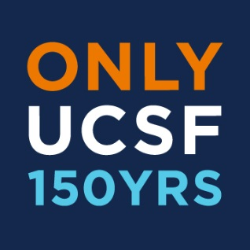

Alumni Association of UCSF
Board of Directors meeting
Tuesday, December 8, 2014
Mission Bay Campus, San Francisco, CA
5:00pm – 7:25pm PST

5:00pm – 5:50pm Tour

6:00pm – 5:55pm Welcome and Introductions Susan Walczak, President

5:55pm – 6:15pm Guest Speaker Daniel Shefer
No votes Social Finance

6:25pm – 6:35pm 150th Anniversary Alumni Excellence Awards Susan Walczak, President
Andrew Kaufteil

6:35pm – 6:50pm Committee Reports – (~3 minutes each)
- 6:35pm – 6:38pm Alumni Weekend: Shawn Houghtaling
- 6:39pm – 6:42pm Alumni-Student Engagement: Todd Golden
- 6:43pm – 6:46pm Diversity & Outreach: Biana Roykh
- 6:47pm – 6:50pm Advocacy: Debra Vails-Qualters
- 6:50pm – 6:55pm Alejandra Rincon, Motion for Black History event

6:55pm – 7:00pm AAUCSF document archive website Dan Keller, Treasurer

7:20pm – 7:25pm New Items Andrew Kaufteil

7:25pm Meeting Adjourned

2015 remaining meeting dates:
March 10, 2015
June 23, 2015

